
2006-2007 Student Council Annualized Funds Application
CIO Name: Outdoors at UVA

CIO Address: PO Box 400444
Charlottesville, VA 22903

President Name: Patrick Case Taintor
President E-mail: pct3d@virginia.edu

Treasurer Name: Sophie Marie Johnson
Treasurer Email: smj9g@virginia.edu

On my honor as a student, the enclosed information is accurate to the best of my knowledge. (The Honor Pledge is acknowledged by submission to the Appropriations Committee.)

Part a: Total S.A.F. Fundable Expenditures
Total PART A: 40,672.10 33,625.84

Equipment and Room Rentals: 9,467.60 6611.34
Outdoors at UVA, the University of Virginia’s student-run Outing Club, is continuing to rapidly expand. Last year, the club grew to over 500 active members from 369 in the previous year. This year, we currently have 632 paying members. By the end of the summer, we expect the membership to grow by about 40 members. Outdoors at UVA is not only one of the University’s largest CIOs, it is also one of the most active. Club members have already led 193 trips since the beginning of this academic year, which averages to almost 1 trip per day. Trips range from mountain biking at nearby Walnut Creek Park to rock climbing at the world famous Red Rocks of Nevada. Because of the constant increase in both the club’s size and trip activity, we need funding from Student Council for our expected expenditures. The money we receive will be used to increase the amount of available equipment for our expanding membership base, to replace worn equipment for safety and convenience, and to fund travel.

Climbing is Outdoors at UVA’s most popular activity. We have a very active and experienced group of climbers, who lead trips ranging from instructing complete beginners in outdoor climbing workshops to weekends sport climbing at the renowned New River Gorge in West Virginia. As the membership base of the club increases, the demand for climbing trips, especially for indoor, beginner outdoor, and intermediate outdoor climbing trips, increases proportionately. To accommodate this increase in trip activity we need more equipment. It is also extremely important that we replace old or worn equipment for safety purposes. With the intense amount of use that our equipment is being put through, we need to replace webbing, ropes, and harnesses for the safety of our members this year. We also need to buy other climbing items such as climbing chalk, chalk bags, and climbing packs.

Hiking, backpacking, and camping are also well attended activities. This year the club has enjoyed many weekend backpacking trips in Virginia and West Virginia. These trips were led by experienced and enthusiastic trip leaders, who were willing to teach members the basics of backpacking. Day hike trips to different trails in Shenandoah National Park have also been plentiful. To support these trips, the club would like to purchase more headlamps, tarps, tents, and some trekking poles. The trekking poles would be useful on our more physically intense backpacking trips.

Although this kayak and canoe season has not been as good as we expected due to low springtime water levels, we are optimistic about the rest of this school year, as well as next year’s season. The club creates opportunities for beginner kayakers to learn the basics of kayaking, including the Eskimo roll, wet exiting, and the T-rescue, and provides whitewater kayaking trips on rivers for more advanced kayakers as well. To accommodate drivers on kayaking trips, we need roof racks with kayak stackers to replace a trailer that a member of the club used to have available. We also need new paddles for the club’s 2 canoes. Finally, the club would like whistles to increase our level of safety by enhancing our communication ability on the water.

Charlottesville provides excellent nearby opportunities for mountain biking. The club often leads trips to nearby Walnut Creek Park, Panorama Farms, and Sherando Lake. Mountain biking trips are always in high demand, and the number of attendees on a created trip is often limited by the number of bikes the club owns, as many members do not own their own mountain bikes. Right now the club has 5 mountain bikes, and as many as 15 or more members are known to sign up for our mountain biking trips. We would like to increase the number of club mountain bikes by 2 so that more members could attend a created mountain bike trip.

The club also needs to purchase miscellaneous items for our club trips, including first aid supplies to restock our first aid kit, guidebooks for hiking and climbing, and national park passes. We also lead many trips that we did not cover in our above club expenditure description, including horseback riding, skydiving, skiing, and whitewater rafting. The club needs additional funds for gas and lodging on these trips.

In summation, Outdoors at UVA is continuing to expand its membership base. We feel that we have successfully provided the school instruction in outdoor sports, an opportunity for constructive social interaction between students, leadership opportunities for trip organizers, and a great deal of experiences in the outdoors. We hope that the Student Council will continue to support our extremely active and continuously expanding CIO.

Itemized List on Following Page

Equipment Name | Quantity | Unit Price | Total Price
Mountain Hardware Switch (20 deg) sleeping bag | 5 | $ 125.00 55 | $ 625.00 275
First Aid Kits | 3 | $ 19.95 | $ 59.85
First Aid Kit replacement set | 2 | $ 12.99 | $ 25.98
NRS rescue throw bag | 1 | $ 67.95 16 | $ 67.95 16
MSR trekking poles | 8 | $ 69.95 50 | $ 559.60 400
TOPO! Outdoor Recreation Mid-Atlantic States mapping software | 1 | $ 99.99 | $ 99.99
National Geographic Park Maps: Shenendoah, New River Gorge, Zion | 3 | $ 9.95 | $ 29.85
MSR MiniWorks EX Microfilter | 2 | $ 79.95 | $ 159.90
Energizer AAA batteries 8-pack | 4 | $ 5.36 | $ 21.44
SealLine Dry Bags | 3 | $ 16.95 | $ 50.85
MSR Outfitter Wing | 1 | $ 279.95 | $ 279.95
REI Half Dome 4 HC Backpacking Tent with footprint | 4 | $ 284.95 | $ 1,139.80
Sunsheild 8X10 Reversible Tarp | 3 | $ 9.96 | $ 29.88
Pro-tec water helmet | 3 | $ 39.95 | $ 119.85
NRS Mambas for cold-weather paddling | 4 | $ 34.95 | $ 139.80
NRS Mystery Sea Hood | 4 | $ 20.00 | $ 80.00
Caves and Caving in Virginia | 1 | $ 12.99 | $ 12.99
Day and Overnight Hikes in Shenedoah National Park | 1 | $ 13.72 | $ 13.72
A Falcon Guide: Hiking West Virginia | 1 | $ 15.95 | $ 15.95
A Falcon Guide: Hiking Virginia | 1 | $ 12.95 | $ 12.95
Mountain Bike! Mid-Atlantic States | 1 | $ 15.95 | $ 15.95
Caving:The Essential Guide to Equipment and Techniques | 1 | $ 21.95 | $ 21.95
The North Face Trailhead 4 - person tent | 2 | $ 329.00 | $ 658.00
Orion Emergency Whistle | 6 | $ 5.25 | $ 31.50
PTC Canoe Paddle | 6 | $ 35.00 | $ 210.00
Yakima Q Tower rack system and Kayak Stacker | 2 | $ 367.00 | $ 734.00
Black Diamond LED Headlamp | 4 | $ 29.95 19.95 | $ 119.80 79.80
Gary Fisher Tassajara Mountain Bike | 2 | $ 575.00 | $ 1,150.00
Dynamic Rope (Beal Apollo II 11mm/50m) | 2 | $ 169.95 | $ 339.90
Dynamic Rope (Beal TopGun II 10.5mm/60m) | 2 | $ 189.95 | $ 379.90
Static Rope (Bluewater II Plus 11mm/120’) | 1 | $ 98.40 | $ 98.40
Webbing (Bluewater Tubular 1’’/325’) | 1 | $ 123.50 | $ 123.50
Dynex Runner (Black Diamond 12mm/60cm) | 10 | $ 7.25 | $ 72.50
Dynex Runner (Black Diamond 12mm/120cm) | 2 | $ 10.95 | $ 21.90
Nut Tool (Black Diamond) | 1 | $ 6.95 | $ 6.95
Helmet (Petzl Ecrin Roc) | 4 | $ 84.00 | $ 336.00
Harness (Black Diamond Mom. AL. S-XL) | 8 | $ 46.95 29.95 | $ 376.00 239.60
Chalk Bag (Arc'Teryx Large) | 5 | $ 19.00 14.95 | $ 95.00 74.75
Climbing Shoes (5.10 Coyote Sz. 5-12) | 10 | $ 75.00 59.95 | $ 750.00 599.50
Chalk (Endo Block. 2 ounces) | 5 | $ 1.05 | $ 5.25
Cordulette Rope (Bluewater 6mm/30') | 2 | $ 9.95 | $ 19.90
Climbing pack (Black Diamond Speed 28L) | 2 | $ 99.95 | $ 199.90
Rope Bag (Black Diamond Super Slacker) | 4 | $ 39.00 34.95 | $ 156.00 139.80
 |  | Total | $ 9,467.60 6611.34

(Note: To insert more rows, move the cursor to the right of the asterisk (*) above, press right arrow button once then press enter)

Speakers expenses: 90
Outside Magazine has sponsored a speaker to come to UVA in the past. Although the speaker is free, we have to provide a hotel room and food costs.
Speaker Breakdown:
Name: | Airfare | Total mileage | mileage Reimb. (@ $0.25 per mile) | Meal Costs ($20/ Day) | Lodging ($70/ Night | total cost For Speaker
Outside Magazine Speaker | 0 | 0 | 0 | 20 | 70 | 90
(Note: To insert more rows, move the cursor to the right of the asterisk (*) above, press right arrow button once then press enter)

Advertising: 60
We would like to purchase advertising space in the Cavalier Daily once in the fall and once in the spring.
Itemized List:
Item: | Quantity | Cost Per Unit | total cost
Cavalier Daily Ad | 2 | 30 | 60
(Note: To insert more rows, move the cursor to the right of the asterisk (*) above, press right arrow button once then press enter)

Member Travel: 30,727 26,537
Member travel is certainly a major element of our budget. Although there are many trips to local areas, most trips are further away and require gas reimbursements. The excel sheet below lists all of our expected trips based upon past years and continued growth. Many costs included in this excel sheet are used for later parts of the budget. To keep costs low, you will see that we cap lodging at $5/person/night. We also require members to buy their own plane tickets.
We have tried to make it easy for you to make changes to the member travel as you see fit. To do so, double click anywhere on the next page and then edit the cells that you wish to edit. The change will be reflected in the totals.

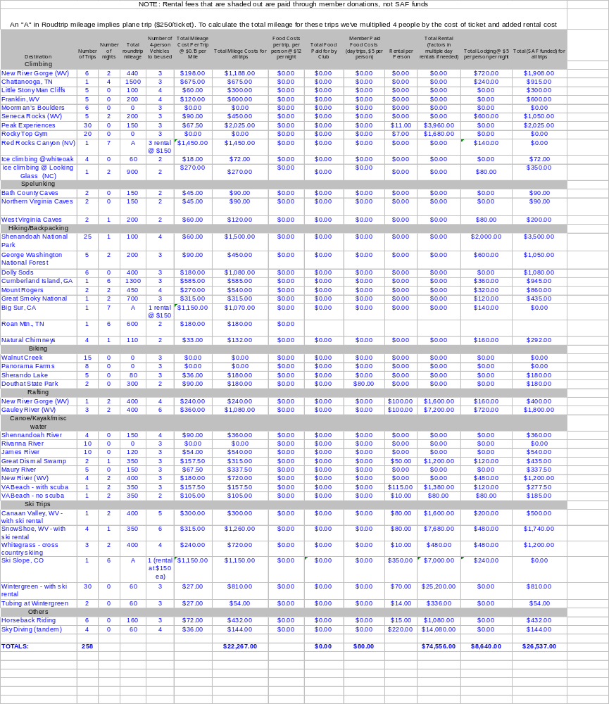

National dues and Registration Fees: 320
Entrance to Shenandoah National Park requires a park pass. The table includes day passes for most cars on trips and year-long passes for members who lead hiking trips very frequently.
We have also included activity fair fees.
Itemized List:
Item | Quantity | Cost Per Unit | total cost
Shenandoah National Park Pass (day pass) | 20 | 10 | 200
Shenandoah National Park Pass (year pass for frequent hiking leaders) | 3 | 30 | 90
Fall Activities Fair | 1 | 15 | 15
Spring Activities Fair | 1 | 15 | 15
(Note: To insert more rows, move the cursor to the right of the asterisk (*) above, press right arrow button once then press enter)

Office Supplies: 0
(Note: To insert more rows, move the cursor to the right of the asterisk (*) above, press right arrow button once then press enter)

Printing and Copying: 7.50
We bring waivers to the fall activities fair so that people can join our club. The other printing costs are for flyers at the activities fair.
Itemized List:
Item | Quantity | Cost Per Unit | total cost
Liability Waivers | 150 | 0.01 | 1.50
Flyers for 2 Activity Fairs | 600 | 0.01 | 6.00
 |  |  | *
(Note: To insert more rows, move the cursor to the right of the asterisk (*) above, press right arrow button once then press enter)

Telephone: 0

Miscellaneous: 0

Part B: Non-Fundable (Out of Pocket) Expenditures

Total PART B: 18,492 1200

Social: 0
The club does have several potlucks and outdoor-related movie nights each semester, but no club money is used to support these.
Itemized List:
Item | Quantity | Cost Per Unit | total cost
 |  |  | *
(Note: To insert more rows, move the cursor to the right of the asterisk (*) above, press right arrow button once then press enter)

Other Expenses: 18,492 1200
Outdoors at UVA pays for food on overnight trips. We limit this amount to $12/person/day, which can generally cover all groceries. In order to limit food expenses, we do not pay for food on day trips. The amount cited for food below is taken from the member travel spreadsheet that is earlier in the budget.
The club also actively encourages members to lead trips. This year we tried to use money as a catalyst by paying a leader the cost of his or her membership upon leading 4 trips.
The club also pays for all gas and lodging for trips that occur over the summer. The cost included below is an estimate based on the trips that occurred last summer.

Itemized List:
Item | Quantity | Cost Per Unit | total cost
Food (itemized on the large excel sheet above) | (see member travel excel sheet) | 12/person/day | 17,292
Dues Refund for Trip Leaders | 10 | 30 | 300
Summer Trips | 30 | $30/trip | 900
(Note: To insert more rows, move the cursor to the right of the asterisk (*) above, press right arrow button once then press enter)
Part C: Non-SAF Funds (self Generated Revenues)

Total PART C: $19,900

Membership Dues: $19,200
Currently, it costs $30 to join the club for an entire year (12 months from when we receive payment) and $20 to join for 5 months. Below are the total dues amounts from last year, the current year, and next year’s projected amounts.
Itemized List:
category | Number | Amount | income
2004-2005 Full Memberships | 389 | $30 | $11,670
2004 Fall Memberships | 18 | $20 | $360
2005 Spring/Summer Memberships (projected) | 94 | $20 | $1880
TOTAL 2004-2005 Dues | 501 | - | $13,910
2005-2006 Full Memberships (projected) | 537 (560) | $30 | $16,110 ($16,800)
2005-2006 5-Month Memberships | 95 (110) | $20 | $1,900 ($2,200)
TOTAL 2005-2006 Dues (projected) | 632 | - | $18,010 ($19,000)
Projected 2006-2007 Year Memberships | 560 | $30 | $16,800
Projected 5-month memberships | 120 | $20 | $2,400
TOTAL Projected 2006-2007 | 680 | - | $19,200

(Note: To insert more rows, move the cursor to the right of the asterisk (*) above, press right arrow button once then press enter)

Donations: 0
Itemized List:
type | Amount | Notes

(Note: To insert more rows, move the cursor to the right of the asterisk (*) above, press right arrow button once then press enter)

Fundraising Revenue: 700
We generate funds from member dues, but we do sell t-shirts throughout the year and make a fair amount of money on them.
Itemized List:
Item | Quantity | Income Per Unit | total Income
T-shirts | 200 | $2.50 | $700
 |  |  | *
(Note: To insert more rows, move the cursor to the right of the asterisk (*) above, press right arrow button once then press enter)

